**myPortfolio: Easy Way to Create Your Amazing Portfolio**

DESCRIPTION

**Project Objective:**

As a Full Stack Developer, you have to create a frontend for the myPortfolio application.

**Background of the problem statement:**

In the third sprint, the scrum team agreed to develop the frontend of the application using an Angular framework. Since you were recently trained in working on this framework, you’re chosen to lead this project and complete the initial part of the application. You agree to complete this task as early as possible, as the release of the application is next week.

**Creating a new project**

* Angular has been installed in your practice labs using npm (Refer FSD: Lab Guide - Phase 4)
* To verify the installation:
  + Open the command-line interface
  + Type in the command:

**ng --version**

* Create a new project using the command:

*ng new angular-app*

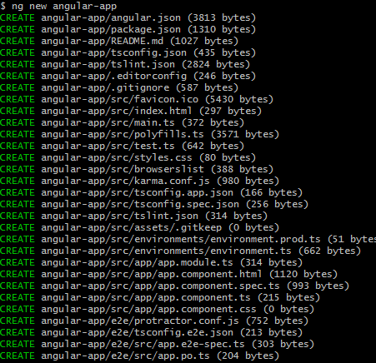

* Move the code to the application folder and start the server.

*cd angular-app*

*ng serve*

**Creating Angular components**

* Open Visual Studio Code
* Navigate to the created myPortfolio project folder.

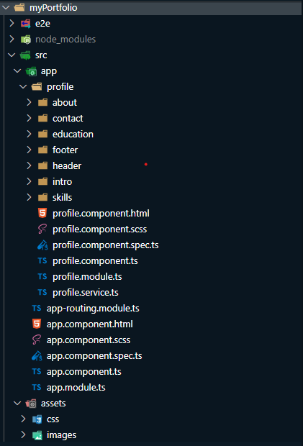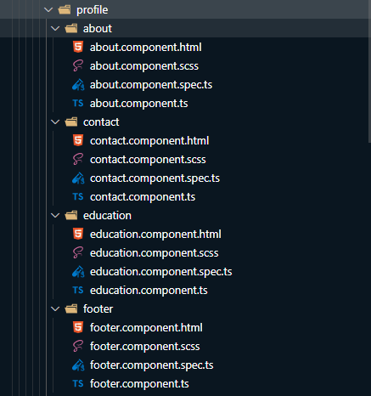

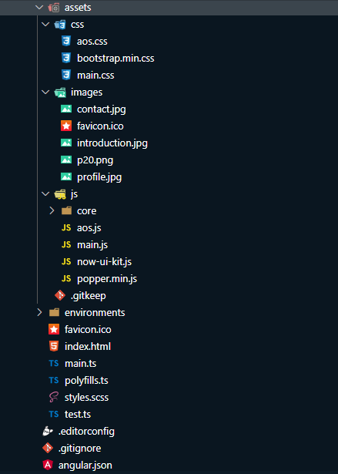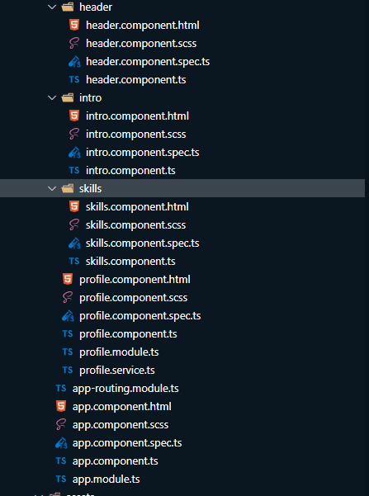

**Open Src/app/index.html**

<!doctype*html*>

<html*lang*="en">

<head>

  <meta*charset*="utf-8">

  <title>PersonalPortfoliAngular</title>

  <base*href*="/">

  <meta*name*="viewport"*content*="width=device-width, initial-scale=1">

  <link*href*="https://fonts.googleapis.com/css?family=Montserrat:400,700,200"*rel*="stylesheet" />

  <link*href*="https://use.fontawesome.com/releases/v5.0.6/css/all.css"*rel*="stylesheet">

  <link*href*="https://maxcdn.bootstrapcdn.com/font-awesome/latest/css/font-awesome.min.css"*rel*="stylesheet">

  <link*href*="assets/css/aos.css"*rel*="stylesheet">

  <link*href*="assets/css/bootstrap.min.css"*rel*="stylesheet">

  <link*href*="assets/css/main.css"*rel*="stylesheet">

  <link*rel*="icon"*type*="image/x-icon"*href*="favicon.ico">

</head>

<body>

  <app-root></app-root>

  <script*src*="https://ajax.googleapis.com/ajax/libs/jquery/3.5.1/jquery.min.js"></script>

  <script*src*="assets/js/core/popper.min.js"></script>

  <script*src*="assets/js/core/bootstrap.min.js"></script>

  <script*src*="assets/js/now-ui-kit.js?v=1.3.0"></script>

  <script*src*="assets/js/aos.js"></script>

  <script*src*="assets/js/main.js"></script>

</body>

</html>

**Create a folder name it as profile**

**In Profile folder Create sub folder name it as about**

**Create about.component.html**

<div class="section" id="about">

    <div class="container">

        <div class="card" data-aos="fade-up" data-aos-offset="10">

            <div class="row">

                <div class="col-lg-6 col-md-12">

                    <div class="card-body">

                        <div class="h4 mt-0 title">About Me</div>

                            <p align="justify">From a young age, I’ve always had a sense of motivation and passion driving me forward. Whether it’s exploring unique opportunities, learning additional skills, or meeting new people, I bring these values to every experience throughout my life on a personal and professional level.</p>

                            <p align="justify">Lover of innovation and everything related to generate new knowledge.Face problems with a smile and solve them as soon as possible. Very calculated about the time I spend and work I do.</p>

                            <p align="justify">To learn more about me, keep exploring my site or reach out directly.</p>

                    </div>

                </div>

                <div class="col-lg-6 col-md-12">

                    <div class="card-body">

                        <div class="h4 mt-0 title">Basic Information</div>

                        <div class="row">

                            <div class="col-sm-4">

                                <strong class="text-uppercase">Date of Birth:</strong>

                            </div>

                            <div class="col-sm-8">F dec 03, 1999</div>

                        </div>

                        <div class="row mt-4">

                            <div class="col-sm-4">

                                <strong class="text-uppercase">Email:</strong>

                            </div>

                            <div class="col-sm-8">pranayteja379@gmail.com</div>

                        </div>

                        <div class="row mt-4">

                            <div class="col-sm-4">

                                <strong class="text-uppercase">Mobile No:</strong>

                            </div>

                            <div class="col-sm-8">8121268386</div>

                        </div>

                        <div class="row mt-4">

                            <div class="col-sm-4">

                                <strong class="text-uppercase">Address:</strong>

                            </div>

                            <div class="col-sm-8">hyderabad,517131</div>

                        </div>

                        <div class="row mt-4">

                            <div class="col-sm-4">

                                <strong class="text-uppercase">Language:</strong>

                            </div>

                            <div class="col-sm-8">Telugu,hindhi,English</div>

                        </div>

                     </div>

                </div>

            </div>

        </div>

    </div>

</div>

**Create about.component.css**

**Create about.component.spec.ts**

import { async, ComponentFixture, TestBed } from'@angular/core/testing';

import { AboutComponent } from'./about.component';

describe('AboutComponent', () => {

  letcomponent:AboutComponent;

  letfixture:ComponentFixture<AboutComponent>;

  beforeEach(async(() => {

    TestBed.configureTestingModule({

      declarations: [ AboutComponent ]

    })

    .compileComponents();

  }));

  beforeEach(() => {

    fixture=TestBed.createComponent(AboutComponent);

    component=fixture.componentInstance;

    fixture.detectChanges();

  });

  it('should create', () => {

    expect(component).toBeTruthy();

  });

});

**Create about.components.ts**

import { Component, OnInit } from'@angular/core';

@Component({

  selector:'app-about',

  templateUrl:'./about.component.html',

  styleUrls: ['./about.component.scss']

})

exportclassAboutComponent*implements*OnInit {

  constructor() { }

  ngOnInit():void {

  }

}

**In Profile folder Create sub folder name it as content**

**Create contact.component.html**

<div*class*="section"*id*="contact">

    <div*class*="cc-contact-information"*style*="background-image: url('assets/images/contact.jpg');">

      <div*class*="container">

        <div*class*="cc-contact">

          <div*class*="row">

            <div*class*="col-md-9">

              <div*class*="card mb-0"*data-aos*="zoom-in">

                <div*class*="h4 text-center title">Contact Me</div>

                <div*class*="row">

                  <div*class*="col-md-6">

                    <div*class*="card-body">

                      <form*name*="form"*(ngSubmit)*="f.form.valid ; f.resetForm()"*#f*="ngForm"*novalidate*>

                        <div*class*="p pb-3">

                          <strong>Feel free to contact me </strong>

                        </div>

                        <div*class*="row mb-3">

                          <div*class*="col">

                            <div*class*="input-group">

                              <input*class*="form-control"*type*="text"*name*="name"*#nameplaceholder*="Name"

*[(ngModel)]*="model.name"*#name*="ngModel"

*[ngClass]*="{ 'is-invalid': f.submitted && name.invalid }"*required* />

                            </div>

                          </div>

                        </div>

                        <div*class*="row mb-3">

                          <div*class*="col">

                            <div*class*="input-container">

                              <input*class*="form-control"*type*="text"*name*="subject"*#subjectplaceholder*="Subject"

*[(ngModel)]*="model.subject"*#subject*="ngModel"

*[ngClass]*="{ 'is-invalid': f.submitted && subject.invalid }"*required* />

                            </div>

                          </div>

                        </div>

                        <div*class*="row mb-3">

                          <div*class*="col">

                            <div*class*="input-group">

                              <input*class*="form-control"*type*="text"*name*="email"  *#emailplaceholder*="E-mail"

*[(ngModel)]*="model.email"*#email*="ngModel"

*[ngClass]*="{ 'is-invalid': f.submitted && email.invalid }"

*pattern*="^([a-zA-Z0-9_\-\.]+)@([a-zA-Z0-9_\-\.]+)\.([a-zA-Z]{2,5})$"*required* />

                            </div>

                          </div>

                        </div>

                        <div*class*="row mb-3">

                          <div*class*="col">

                            <div*class*="form-group">

                              <textarea*class*="form-control"*name*="message"*#messageplaceholder*="Your Message"

*[(ngModel)]*="model.message"*#message*="ngModel"

*[ngClass]*="{ 'is-invalid': f.submitted && message.invalid }"*required*></textarea>

                            </div>

                          </div>

                        </div>

                        <div*class*="row">

                          <div*class*="col">

                            <button*class*="btn btn-primary"*type*="submit"*(click)*="onSubmit(name.value, subject.value, email.value, message.value)"> Send</button>

                          </div>

                        </div>

                      </form>

                    </div>

                  </div>

                  <div*class*="col-md-6">

                    <div*class*="card-body">

                        <p*class*="mb-0">

                            <strong>Phone</strong>

                        </p>

                        <p*class*="pb-2">+91 8919236779</p>

                        <p*class*="mb-0">

                            <strong>Email</strong>

                        </p>

                        <p>rahulkumar.nidamanuri@gmail.com</p>

                    </div>

                </div>

                </div>

              </div>

            </div>

          </div>

        </div>

      </div>

    </div>

  </div>

  <ng-snotify*class*="material"></ng-snotify>

**Create contact.component.scss**

**Create contact.component.spec.ts**

import { async, ComponentFixture, TestBed } from'@angular/core/testing';

import { ContactComponent } from'./contact.component';

describe('ContactComponent', () => {

  letcomponent:ContactComponent;

  letfixture:ComponentFixture<ContactComponent>;

  beforeEach(async(() => {

    TestBed.configureTestingModule({

      declarations: [ ContactComponent ]

    })

    .compileComponents();

  }));

  beforeEach(() => {

    fixture=TestBed.createComponent(ContactComponent);

    component=fixture.componentInstance;

    fixture.detectChanges();

  });

  it('should create', () => {

    expect(component).toBeTruthy();

  });

});

**Create contact.component.ts**

import { Component, OnInit } from'@angular/core';

import { HttpClient } from'@angular/common/http';

import { HttpHeaders} from'@angular/common/http';

import { ProfileService } from'../profile.service';

import { SnotifyService } from'ng-snotify';

import { environment } from'../../../environments/environment';

@Component({

  selector:'app-contact',

  templateUrl:'./contact.component.html',

  styleUrls: ['./contact.component.scss']

})

  exportclassContactComponent*implements*OnInit {

    model:any= {};

    constructor(

*private*http:HttpClient

    ){}

    ngOnInit() {

       }

       onSubmit(name, subject, email, message) {

          constheaders=newHttpHeaders({ 'Content-Type':'application/json' });

          this.http.post('https://formspree.io/f/mwkwpzve',

            { name:name, subject:subject, replyto:email, message:message },

            { 'headers':headers }).subscribe(

              response=> {

                console.log(response);

              }

            );

        }

}

**In Profile folder Create sub folder name it as education**

**Create education.component.html**

<div class="section" id="education">

    <div class="container cc-education">

        <div class="h4 text-center mb-4 title">Education</div>

            <div class="card">

                <div class="row">

                    <div class="col-md-3 bg-primary" data-aos="fade-right" data-aos-offset="50" data-aos-duration="500">

                        <div class="card-body cc-education-header">

                            <p>2016-2020</p>

                        <div class="h5">Bachelor Degree</div>

                        </div>

                    </div>

                    <div class="col-md-9" data-aos="fade-left" data-aos-offset="50" data-aos-duration="500">

                        <div class="card-body">

                            <div class="h4">Bachelor of Engineering</div>

                                <h4 class="category">CMR Enginering College</h4>

                                <ul>

                                    <li> QIS College Of Engineering and Technology <b>ranks 2st</b> in Chennai </li>

                                        <li>Completed B-tech in Computer Science and Engineering with <b>83% </b>.</li>

                                </ul>

                        </div>

                    </div>

                </div>

            </div>

            <div class="card">

                <div class="row">

                    <div class="col-md-3 bg-primary" data-aos="fade-right" data-aos-offset="50" data-aos-duration="500">

                        <div class="card-body cc-education-header">

                            <p>2014-2016</p>

                        <div class="h5">Secondary education</div>

                        </div>

                    </div>

                    <div class="col-md-9" data-aos="fade-left" data-aos-offset="50" data-aos-duration="500">

                        <div class="card-body">

                            <div class="h4">Inter MPC</div>

                            <h4 class="category">Sri Chaitanya jr College</h4>

                            <ul>

                                    <li>Completed secondary education with <b>81.3%</b> aggregate.</li>

                            </ul>

                        </div>

                    </div>

                </div>

            </div>

            <div class="card">

                <div class="row">

                    <div class="col-md-3 bg-primary" data-aos="fade-right" data-aos-offset="50" data-aos-duration="500">

                        <div class="card-body cc-education-header">

                            <p>2014</p>

                        <div class="h5">Primary education</div>

                        </div>

                    </div>

                    <div class="col-md-9" data-aos="fade-left" data-aos-offset="50" data-aos-duration="500">

                        <div class="card-body">

                            <div class="h5">English Medium</div>

                                <h4 class="category">Government High Schoole</h4>

                                <ul>

                                        <li>Completed with <b>80% </b>aggregate.</li>

                                </ul>

                        </div>

                    </div>

                </div>

            </div>

        </div>

</div>

**Create education.component.scss**

**Create education.component.spec.ts**

import { async, ComponentFixture, TestBed } from'@angular/core/testing';

import { EducationComponent } from'./education.component';

describe('EducationComponent', () => {

  letcomponent:EducationComponent;

  letfixture:ComponentFixture<EducationComponent>;

  beforeEach(async(() => {

    TestBed.configureTestingModule({

      declarations: [ EducationComponent ]

    })

    .compileComponents();

  }));

  beforeEach(() => {

    fixture=TestBed.createComponent(EducationComponent);

    component=fixture.componentInstance;

    fixture.detectChanges();

  });

  it('should create', () => {

    expect(component).toBeTruthy();

  });

});

**Create education.component.ts**

import { Component, OnInit } from'@angular/core';

@Component({

  selector:'app-education',

  templateUrl:'./education.component.html',

  styleUrls: ['./education.component.scss']

})

exportclassEducationComponent*implements*OnInit {

  constructor() { }

  ngOnInit():void {

  }

}

**In Profile folder Create sub folder name it as footer**

**Create footer.component.html**

<footer*class*="footer">

    <div*class*="container text-center">

        <a*class*="cc-facebook btn btn-link"*href*="https://www.facebook.com/Mr.YuvaKeratam/"*target*="_blank">

            <i*class*="fa fa-facebook fa-2x "*aria-hidden*="true"></i>

        </a>

        <a*class*="cc-instagram btn btn-link"*href*="https://www.instagram.com/mr.yuvakeratam/"*target*="_blank">

            <i*class*="fa fa-instagram fa-2x "*aria-hidden*="true"></i>

        </a>

        <a*class*="cc-github btn btn-link "*href*="https://https://github.com/NidamanuriRahulKumar/"*target*="_blank">

            <i*class*="fa fa-github fa-2x "*aria-hidden*="true"></i>

        </a>

    </div>

    <div*class*="text-center text-muted">

        <p>&copy; All rights reserved.</p>

    </div>

</footer>

**Create footer.component.scss**

**Create footer.component.spec.ts**

import { async, ComponentFixture, TestBed } from'@angular/core/testing';

import { FooterComponent } from'./footer.component';

describe('FooterComponent', () => {

  letcomponent:FooterComponent;

  letfixture:ComponentFixture<FooterComponent>;

  beforeEach(async(() => {

    TestBed.configureTestingModule({

      declarations: [ FooterComponent ]

    })

    .compileComponents();

  }));

  beforeEach(() => {

    fixture=TestBed.createComponent(FooterComponent);

    component=fixture.componentInstance;

    fixture.detectChanges();

  });

  it('should create', () => {

    expect(component).toBeTruthy();

  });

});

**Create footer.component.ts**

import { Component, OnInit } from'@angular/core';

@Component({

  selector:'app-footer',

  templateUrl:'./footer.component.html',

  styleUrls: ['./footer.component.scss']

})

exportclassFooterComponent*implements*OnInit {

  constructor() { }

  ngOnInit():void {

  }

}

**In Profile folder Create sub folder name it as header**

**Create header.component.html**

<header>

    <div*class* = "profile-page sidebar-collapse">

        <nav*class*="navbar navbar-expand-lg fixed-top navbar-transparent bg-primary"*color-on-scroll*="400">

            <div*class*="container">

            <div*class*="navbar-translate">

                <a*class*="navbar-brand"*href*="#"*rel*="tooltip">Mr.YuvaKeratam</a>

                <button*class*="navbar-toggler navbar-toggler"*type*="button"*data-toggle*="collapse"*data-target*="#navigation"*aria-controls*="navigation"*aria-expanded*="false"*aria-label*="Toggle navigation">

                    <span*class*="navbar-toggler-bar bar1"></span>

                    <span*class*="navbar-toggler-bar bar2"></span>

                    <span*class*="navbar-toggler-bar bar3"></span>

                </button>

            </div>

            <div*class*="collapse navbar-collapse justify-content-end"*id*="navigation">

                <ul*class*="navbar-nav">

                  <li*class*="nav-item">

                    <a*class*="nav-link smooth-scroll"*href*="#about">About</a>

                  </li>

                    <li*class*="nav-item">

                    <a*class*="nav-link smooth-scroll"*href*="#skill">Skills</a>

                  </li>

                  <li*class*="nav-item">

                    <a*class*="nav-link smooth-scroll"*href*="#education">Education</a>

                  </li>

                  <li*class*="nav-item">

                      <a*class*="nav-link smooth-scroll"*href*="#reference">Reference</a>

                    </li>

                  <li*class*="nav-item">

                    <a*class*="nav-link smooth-scroll"*href*="#contact">Contact</a>

                  </li>

                </ul>

              </div>

            </div>

        </nav>

    </div>

</header>

**Create header.component.scss**

**Create header.component.spec.ts**

import { async, ComponentFixture, TestBed } from'@angular/core/testing';

import { HeaderComponent } from'./header.component';

describe('HeaderComponent', () => {

  letcomponent:HeaderComponent;

  letfixture:ComponentFixture<HeaderComponent>;

  beforeEach(async(() => {

    TestBed.configureTestingModule({

      declarations: [ HeaderComponent ]

    })

    .compileComponents();

  }));

  beforeEach(() => {

    fixture=TestBed.createComponent(HeaderComponent);

    component=fixture.componentInstance;

    fixture.detectChanges();

  });

  it('should create', () => {

    expect(component).toBeTruthy();

  });

});

**Create header.component.ts**

import { Component, OnInit } from'@angular/core';

@Component({

  selector:'app-header',

  templateUrl:'./header.component.html',

  styleUrls: ['./header.component.scss']

})

exportclassHeaderComponent*implements*OnInit {

  constructor() { }

  ngOnInit():void {

  }

}

**In Profile folder Create sub folder name it as intro**

**Create intro.component.html**

<div*class*="profile-page">

    <div*class*="wrapper">

        <div*class*="page-header page-header-small"*filter-color*="orange">

            <div*class*="page-header-image"*data-parallax*="true"*style*="background-image: url('assets/images/introduction.jpg');">

            </div>

        <div*class*="container">

            <div*class*="content-center">

                <div*class*="profile-image">

                    <a*href*="#">

                        <img*src*="assets/images/profile.jpg"*alt*="Image" />

                    </a>

                </div>

                <div*class*="h2 title">Nidamanuri Rahul Kumar</div>

                <p*class*="category text-white">Java Full STack Developer</p>

                <a*class*="btn btn-primary smooth-scroll mr-2"*href*="#contact"*data-aos*="zoom-in"*data-aos-anchor*="data-aos-anchor">Hire Me</a>

                <a*class*="btn btn-primary"*href*="https://docs.google.com/document/d/1HSVZPYX0c_d6fkFsfNOAAnb3--LGD2Lo/edit?usp=sharing&ouid=105500183977979454287&rtpof=true&sd=true"*target*="_blank"*data-aos*="zoom-in"*data-aos-anchor*="data-aos-anchor">Download CV</a>

            </div>

        </div>

        <div*class*="section">

            <div*class*="container">

                <div*class*="button-container">

                    <a*class*="btn btn-default btn-round btn-lg btn-icon"*href*="https://www.facebook.com/Mr.YuvaKeratam/"*target*="_blank"*rel*="tooltip"*title*="Follow me on Facebook">

                        <i*class*="fa fa-facebook"></i>

                    </a>

                    <a*class*="btn btn-default btn-round btn-lg btn-icon"*href*="https://www.instagram.com/mr.yuvakeratam/"*target*="_blank"*rel*="tooltip"*title*="Follow me on Linkedin">

                        <i*class*="fa fa-linkedin"></i>

                    </a>

                    <a*class*="btn btn-default btn-round btn-lg btn-icon"*href*="https://github.com/NidamanuriRahulKumar/"*target*="_blank"*rel*="tooltip"*title*="Follow me on Github">

                        <i*class*="fa fa-github"></i>

                    </a>

                </div>

            </div>

        </div>

        </div>

    </div>

</div>

**Create intro.component.scss**

**Create intro.component.spec.ts**

import { async, ComponentFixture, TestBed } from'@angular/core/testing';

import { IntroComponent } from'./intro.component';

describe('IntroComponent', () => {

  letcomponent:IntroComponent;

  letfixture:ComponentFixture<IntroComponent>;

  beforeEach(async(() => {

    TestBed.configureTestingModule({

      declarations: [ IntroComponent ]

    })

    .compileComponents();

  }));

  beforeEach(() => {

    fixture=TestBed.createComponent(IntroComponent);

    component=fixture.componentInstance;

    fixture.detectChanges();

  });

  it('should create', () => {

    expect(component).toBeTruthy();

  });

});

**Create intro.component.ts**

import { Component, OnInit } from'@angular/core';

@Component({

  selector:'app-intro',

  templateUrl:'./intro.component.html',

  styleUrls: ['./intro.component.scss']

})

exportclassIntroComponent*implements*OnInit {

  constructor() { }

  ngOnInit():void {

  }

}

**In Profile folder Create sub folder name it as skills**

**Create skills.component.html**

<div*class*="section"*id*="skill">

    <div*class*="container">

      <div*class*="h4 text-center mb-4 title">Skills</div>

      <div*class*="card"*data-aos*="fade-up"*data-aos-anchor-placement*="top-bottom">

        <div*class*="card-body">

          <div*class*="row">

            <div*class*="col-md-6">

              <div*class*="progress-container progress-primary">

                <span*class*="progress-badge">Java</span>

                <div*class*="progress">

                  <div*class*="progress-bar progress-bar-primary"*data-aos*="progress-full"*data-aos-offset*="10"

*data-aos-duration*="2000"*role*="progressbar"*aria-valuenow*="60"*aria-valuemin*="0"*aria-valuemax*="100"

*style*="width: 85%;"></div>

                  <span*class*="progress-value">85%</span>

                </div>

              </div>

            </div>

          <div*class*="row">

            <div*class*="col-md-6">

              <div*class*="progress-container progress-primary">

                <span*class*="progress-badge">Spring Framework</span>

                <div*class*="progress">

                  <div*class*="progress-bar progress-bar-primary"*data-aos*="progress-full"*data-aos-offset*="10"

*data-aos-duration*="2000"*role*="progressbar"*aria-valuenow*="60"*aria-valuemin*="0"*aria-valuemax*="100"

*style*="width: 70%;"></div>

                  <span*class*="progress-value">70%</span>

                </div>

              </div>

            </div>

            <div*class*="col-md-6">

              <div*class*="progress-container progress-primary">

                <span*class*="progress-badge">Angular8</span>

                <div*class*="progress">

                  <div*class*="progress-bar progress-bar-striped progress-bar-animated"*data-aos*="progress-full"*data-aos-offset*="10"

*data-aos-duration*="2000"*role*="progressbar"*aria-valuenow*="60"*aria-valuemin*="0"*aria-valuemax*="100"

*style*="width: 60%;"></div>

                  <span*class*="progress-value">60%</span>

                </div>

              </div>

            </div>

          </div>

          <div*class*="row">

            <div*class*="col-md-6">

              <div*class*="progress-container progress-primary">

                <span*class*="progress-badge">RDBMS</span>

                <div*class*="progress">

                  <div*class*="progress-bar progress-bar-primary"*data-aos*="progress-full"*data-aos-offset*="10"

*data-aos-duration*="2000"*role*="progressbar"*aria-valuenow*="60"*aria-valuemin*="0"*aria-valuemax*="100"

*style*="width: 75%;"></div>

                  <span*class*="progress-value">75%</span>

                </div>

              </div>

            </div>

            <div*class*="col-md-6">

              <div*class*="progress-container progress-primary">

                <span*class*="progress-badge">HTML,CSS,JS</span>

                <div*class*="progress">

                  <div*class*="progress-bar progress-bar-primary"*data-aos*="progress-full"*data-aos-offset*="10"

*data-aos-duration*="2000"*role*="progressbar"*aria-valuenow*="60"*aria-valuemin*="0"*aria-valuemax*="100"

*style*="width: 70%;"></div>

                  <span*class*="progress-value">70%</span>

                </div>

              </div>

            </div>

          </div>

        </div>

      </div>

    </div>

  </div>

**Create skills.component.scss**

**Create skills.component.spec.ts**

import { async, ComponentFixture, TestBed } from'@angular/core/testing';

import { SkillsComponent } from'./skills.component';

describe('SkillsComponent', () => {

  letcomponent:SkillsComponent;

  letfixture:ComponentFixture<SkillsComponent>;

  beforeEach(async(() => {

    TestBed.configureTestingModule({

      declarations: [ SkillsComponent ]

    })

    .compileComponents();

  }));

  beforeEach(() => {

    fixture=TestBed.createComponent(SkillsComponent);

    component=fixture.componentInstance;

    fixture.detectChanges();

  });

  it('should create', () => {

    expect(component).toBeTruthy();

  });

});

**Create skills.component.ts**

import { Component, OnInit } from'@angular/core';

@Component({

  selector:'app-skills',

  templateUrl:'./skills.component.html',

  styleUrls: ['./skills.component.scss']

})

exportclassSkillsComponent*implements*OnInit {

  constructor() { }

  ngOnInit():void {

  }

}

**In Profile create profile.component.html**

<app-header></app-header>

<div*class* ="page-content">

    <app-intro></app-intro>

    <app-about></app-about>

    <app-skills></app-skills>

    <app-education></app-education>

    <app-contact></app-contact>

</div>

<app-footer></app-footer>

<ngx-spinner*bdColor*="rgba(255,255,255,1)"*size*="medium"*color*="#033d5b"*type*="ball-spin-clockwise"></ngx-spinner>

**In Profile create profile.component.scss**

**In Profile create profile.component.spec.ts**

import { async, ComponentFixture, TestBed } from'@angular/core/testing';

import { ProfileComponent } from'./profile.component';

describe('ProfileComponent', () => {

  letcomponent:ProfileComponent;

  letfixture:ComponentFixture<ProfileComponent>;

  beforeEach(async(() => {

    TestBed.configureTestingModule({

      declarations: [ ProfileComponent ]

    })

    .compileComponents();

  }));

  beforeEach(() => {

    fixture=TestBed.createComponent(ProfileComponent);

    component=fixture.componentInstance;

    fixture.detectChanges();

  });

  it('should create', () => {

    expect(component).toBeTruthy();

  });

});

**In Profile create profile.component.ts**

import { Component, OnInit } from'@angular/core';

import { NgxSpinnerService } from'ngx-spinner';

@Component({

  selector:'app-profile',

  templateUrl:'./profile.component.html',

  styleUrls: ['./profile.component.scss']

})

exportclassProfileComponent*implements*OnInit {

  constructor(

*private*spinner:NgxSpinnerService

  ) { }

  ngOnInit() {

    this.spinner.show();

    setTimeout(() => {

        this.spinner.hide();

    }, 2000);

  }

}

**In Profile create profile.module.ts**

import { NgModule } from'@angular/core';

import { CommonModule } from'@angular/common';

import { SnotifyModule, SnotifyService, ToastDefaults } from'ng-snotify';

import { ProfileComponent } from'./profile.component';

import { HeaderComponent } from'./header/header.component';

import { FooterComponent } from'./footer/footer.component';

import { IntroComponent } from'./intro/intro.component';

import { AboutComponent } from'./about/about.component';

import { NgxSpinnerModule } from'ngx-spinner';

import { ContactComponent } from'./contact/contact.component';

import { EducationComponent } from'./education/education.component';

import { SkillsComponent } from'./skills/skills.component';

import {FormsModule,ReactiveFormsModule} from'@angular/forms';

@NgModule({

  imports: [

    CommonModule,

    FormsModule,

    SnotifyModule,

    FormsModule,

    ReactiveFormsModule,

    NgxSpinnerModule

  ],

  declarations: [

    ProfileComponent,

    HeaderComponent,

    FooterComponent,

    AboutComponent,

    IntroComponent,

    ContactComponent,

    EducationComponent,

    SkillsComponent,

  ],

  providers: [

    { provide:'SnotifyToastConfig', useValue:ToastDefaults},

    SnotifyService,

  ]

})

exportclassProfileModule { }

**In profile Create profile.service.ts**

import { Injectable } from'@angular/core';

import { Observable } from'rxjs';

import { HttpClient } from'@angular/common/http';

import { environment } from'../../environments/environment';

@Injectable({

    providedIn:'root'

  })

  exportclassProfileService {

    baseUrl=environment.baseUrl;

  constructor(

*private*http:HttpClient

  ) { }

  contactus(data:any):Observable<any> {

    returnthis.http.post('http://localhost:4200/contact',data);

  }

  }

**In profile open app.component.html**

<router-outlet></router-outlet>

**In profile open app.module.ts**

import { BrowserModule } from'@angular/platform-browser';

import { NgModule } from'@angular/core';

import { AppComponent } from'./app.component';

import { RouterModule, Routes, ExtraOptions } from'@angular/router';

import { ProfileComponent } from'./profile/profile.component';

import { ProfileModule } from'./profile/profile.module';

import { HttpClientModule } from'@angular/common/http';

import {FormsModule,ReactiveFormsModule} from'@angular/forms';

constroutes:Routes= [

  {

    path:'',

    component:ProfileComponent

  }

];

constconfig:ExtraOptions= {

  useHash:true,

};

@NgModule({

  declarations: [

    AppComponent

  ],

  imports: [

    BrowserModule,

    FormsModule,

    ReactiveFormsModule,

    RouterModule.forRoot(routes, config),

    ProfileModule,

    HttpClientModule

  ],

  providers: [],

  bootstrap: [AppComponent]

})

exportclassAppModule { }

**In profile open app.component.spec.ts**

import { TestBed, async } from'@angular/core/testing';

import { RouterTestingModule } from'@angular/router/testing';

import { AppComponent } from'./app.component';

describe('AppComponent', () => {

  beforeEach(async(() => {

    TestBed.configureTestingModule({

      imports: [

        RouterTestingModule

      ],

      declarations: [

        AppComponent

      ],

    }).compileComponents();

  }));

  it('should create the app', () => {

    constfixture=TestBed.createComponent(AppComponent);

    constapp=fixture.componentInstance;

    expect(app).toBeTruthy();

  });

  it(`should have as title 'Personal-Portfolio-Angular'`, () => {

    constfixture=TestBed.createComponent(AppComponent);

    constapp=fixture.componentInstance;

    expect(app.title).toEqual('Personal-Portfolio-Angular');

  });

  it('should render title', () => {

    constfixture=TestBed.createComponent(AppComponent);

    fixture.detectChanges();

    constcompiled=fixture.nativeElement;

    expect(compiled.querySelector('.content span').textContent).toContain('Personal-Portfolio-Angular app is running!');

  });

});

**Open JS folder create file main.js**

*// Add your javascript here*

*// Don't forget to add it into respective layouts where this js file is needed*

$(document).ready(function() {

  AOS.init( {

*// uncomment below for on-scroll animations to played only once*

*// once: true*

  }); *// initialize animate on scroll library*

});

*// Smooth scroll for links with hashes*

$('a.smooth-scroll')

.click(function(event) {

*// On-page links*

  if (

    location.pathname.replace(/^\//, '') == this.pathname.replace(/^\//, '')

    &&

    location.hostname == this.hostname

  ) {

*// Figure out element to scroll to*

    vartarget = $(this.hash);

    target = target.length ? target : $('[name=' + this.hash.slice(1) + ']');

*// Does a scroll target exist?*

    if (target.length) {

*// Only prevent default if animation is actually gonna happen*

      event.preventDefault();

      $('html, body').animate({

        scrollTop: target.offset().top

      }, 1000, function() {

*// Callback after animation*

*// Must change focus!*

        var$target = $(target);

        $target.focus();

        if ($target.is(":focus")) { *// Checking if the target was focused*

*return*false;

        } else {

          $target.attr('tabindex','-1'); *// Adding tabindex for elements not focusable*

          $target.focus(); *// Set focus again*

        };

      });

    }

  }

});

**For Complete SourceCode follow my GitHub**

**To run the project Open Terminal Gitbush**

**Then move to Source folder Cd myPortfolio**

**$ ng serve –open**

**Or**

**$ ng s**

**Pushing the code to your GitHub repositories**

* Open your command prompt and navigate to the folder where you have created your files.

**cd <folder path>**

* Initialize your repository using the following command:

**git init**

* Add all the files to your git repository using the following command:

**git add .**

* Commit the changes using the following command:

**git commit . -m “Changes have been committed.”**

* Push the files to the folder you initially created using the following command:

**git push -u origin master**